
Probe Audit Premium+


Probe Review


Probe Compilation

What’s new 2022.20.13

Index

1. Caseware Working Papers 2022 4
1.1 Features 4
1.1.1 Automatic documents 4
1.1.2 Cloud integration 4
1.2 Fixes 4
1.2.1 CaseView 4
1.2.2 Hybrid Cloud 4
1.2.3 Imports 4
1.2.4 Interface 5
1.2.5 Issues 5
1.2.6 Users and groups 5
2. Universal 6
2.1 Groupings & Sections 6
2.1.1 Class of transaction or account balance 6
2.1.2 Document manager and numbers 6
2.1.3 Leadsheets & Graphs 6
2.2 Materiality 6
2.3 Document look and feel 6
2.3.1 Show (Previously “View”) 7
2.3.2 Roles 7
2.3.3 Setup 7
2.3.4 History 7
2.3.5 Refresh 7
2.3.6 Go to 7
2.3.7 Probe Help (Previously “Help”) 7
2.4 Other improvements 7
2.4.1 Licensing 7
2.4.2 02.40 Evaluation of misstatements 7
2.4.3 Recording dialog 8
2.5 Update process 9
2.6 Fixes 9
2.7 Known issues 9
2.7.1 Cosmetic items 9
2.7.2 Engagement partner sign off drop down 10
2.7.3 Inserting and deleting of rows 10
2.7.4 Recording dialog 10
2.7.5 Work program items 10
2.7.6 Other items 10
3. Audit 11
3.1 ISA 315 (2019 Revised) 11
3.1.1 Obtaining and understanding 11
3.1.2 Identifying and assessing risks of material misstatement 11
3.1.3 Responses to assessed risks 11
3.2 Assertions 11
3.3 Core and Extended options 12
3.4 Risk assessment procedures (RAP) to obtain understanding of the entity and its environment 12
3.5 Transactions related to account balances (TRAB) 12
3.6 Work Program Procedures 13
3.7 Audit procedures flowchart 14
3.8 Pre-engagement planning 15
3.9 Planning and risk assessment procedures 17
3.10 Audit planning 24
3.11 Execution – Lead sheets and working papers 25
4. Review 26
4.1 New sections 26
4.2 Likely to be misstated recording dialog 26
5. Compilation 27
5.1 New sections and leadsheets 27
6. Update document summary 28

Caseware Working Papers 2022
The following describes the features and fixes included in Working Papers 2022 and related products

Features

Automatic documents
- Added the Context selector to uncorrected misstatement type documents in consolidated files.
- Users can select the entity within the consolidated entity structure as context for the document.

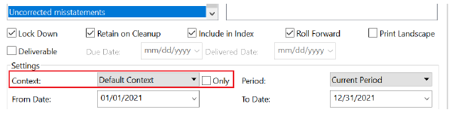

Cloud integration
- When integrating Working Papers with a Cloud site, URLs containing the web protocol (http:// or https://) no longer prevent integration until they are manually removed. The web protocol is now automatically truncated from the URL.
- Added support for the Microsoft Accounts browser extension. User credentials from the extension can now authenticate access to content in Working Papers.

Fixes

CaseView
- Fixed an issue where opening an adjustment in CaseView would cause the active user’s initials to override the creator’s initials.
- Fixed an issue where embedded images sourced from other CaseView documents would fail to load and report an error that the image must be converted to a non-embedded image
- Fixed an issue where some notes in the reference column of the balance sheet displayed in the wrong order.
- Fixed an issue where using Find and Replace to replace a body of text with a shorter piece of text resulted in an error.
- Fixed an issue where users could only edit Form Mode documents if they had edit permissions for Design Mode documents.

Hybrid Cloud
- Fixed an issue where performing a year-end close and roll forward on a file that is both Cloud integrated and published would not roll forward contact information to the file for the next year.
- Fixed an issue where local computers were not scanned for sufficient disk space prior to downloading large sync copies, resulting in an error and partially downloaded file. Insufficient disk space will now prevent the file from downloading.

Imports
- Fixed an issue where the active period of Account View imports would default to yearly, even when it was not applicable.
- Fixed a compatibility issue preventing users from completing imports from E-conomic Online Accounting and Sage One Accounting. IDEA Integration

Interface
- Fixed an issue where the registry repair prompt that displays after installing Windows updates would not correctly repair the registry and would prevent users from accessing Working Papers and Connector.
- Fixed an issue where converting a sync copy to a newer version of Working Papers would result in both the converted and unconverted copies displaying in the Recent Files pane.
- Fixed an issue where files recently published and synchronized with Cloud would display as not fully synchronized in the Recent Files pane.

Issues
- Fixed an issue where new document issues were created with the Roll Forward and Retain on Cleanup options automatically enabled.

Users and groups
- Fixed a synchronization issue that prevented new users from displaying in the Active Directory group they were assigned.
- Fixed an issue where a number indicating a duplication was appended to some usernames after synchronizing with an Active Directory group.
- Fixed an issue where disabling LDAP integration in one group for a user who is in multiple groups would cause them to be flagged as Inactive.

Universal

Groupings & Sections

Class of transaction or account balance
Each class of transaction or account balance (hereafter referred to as “COTAB”) presented in the separate financial statements in accordance with the financial reporting framework will now be treated as a separate section. For those sections that consisted out of more than one account balance or class of transaction, the sections are split to only include one COTAB. For example, Goodwill and Intangible assets, included in section 23, are now split into two sections, 320 Intangible assets and 321 Goodwill.

In Probe Audit, the aforementioned will enable the auditor to identify the risks of material misstatement at assertion level for classes of transactions, account balances and disclosures as required by ISA 315.28&31. The auditor will plan, execute and conclude per individual account balance, class of transaction and other disclosure (hereafter referred to as “COTABD”) presented in the separate financial statements. In Probe Review, it will enable the independent reviewer to identify areas likely to be misstated for classes of transactions, account balances and disclosures.

Document manager and numbers
Because of the change to the groupings and sections, you have an updated document manager. There are main folders under Leadsheets and working papers, which are the classes (Non-current assets, Current assets, Non-current liabilities, Current liabilities, Income, Expenses, Equity). Within each of these folders, is a folder per section. Within each section folder, you will have a total leadsheet, and where applicable, a leadsheet per class.

To accommodate for the increase in number of sections, work programs are now renumbered following a mask of XXX.XX (321.10) where previously it was XX.XX (23.10).

Refer to Annexure A – Sections for detailed changes.

Leadsheets & Graphs
All leadsheets now have a graph available. To enable, click on View > Graphs.
Drill down into a line item to see ratio and relationship graphs.

Materiality
To determine the amount of COTAB and whether the COTAB is material, the transactions related to the account balance (hereafter referred to as “TRAB”) will no longer be included with the account balance; it will be included in the appropriate class of transaction. For example, deprecation and impairment related to property, plant and equipment will not be included in the amount of property, plant and equipment. Depreciation of property, plant and equipment will be included in either cost of sales or operating expenses based on the mapping of the relevant general ledger accounts. Impairment of property, plant and equipment will be included in section operating gains (losses).

Refer to Annexure A – Sections for detailed TRAB inclusions.
Refer to 3.5 Transactions related to account balances (TRAB) for further information how TRAB will be treated in Probe Audit.

Document look and feel
The look and feel of documents have been refreshed to allow for a more intuitive user experience.

Show (Previously “View”)
We have included the new assertions as per the Probe Audit methodology as filter options, refer to 3.2 Assertions for details on assertions.

Roles
You now have the option to jump directly to the Roles Options and change Roles Properties.

Setup
No change

History
A brand-new menu item for you to save milestones as well as see the document history.

Refresh
No change

Go to
A brand-new menu for you to access:
- Calculator
- Adjusting entries
- Other entries
- Working Trial Balance
- Issues
- Highlight issues in the document

Probe Help (Previously “Help”)
The menu was reorganised to provide a more intuitive experience.
The following new items were also added:
- Chat with support – this will take you directly to the support chat dialog.
- Update from hotfix – should a hotfix become available, you can download it from here.

Other improvements
The following list is a brief description of improvements that have been made:

Licensing
We have improved our licensing check and it is no longer required for you to insert all licence codes to have the audit add-ons activated. If you only insert the Probe licence code on install, the Premium, IFRS and SME add-ons will also be activated for relevant users.

02.40 Evaluation of misstatements
Included in 02.40 Evaluation of misstatements, in the Statement of comprehensive income, are the figures for Other comprehensive income.

Recording dialog
The risk record mode received a facelift. Instead of the table, spread across multiple pages, you will now be able to record a risk within a dialog in CaseView. In this dialog, you will be able to view your complete risk, control or item likely to be misstated for Probe Review.
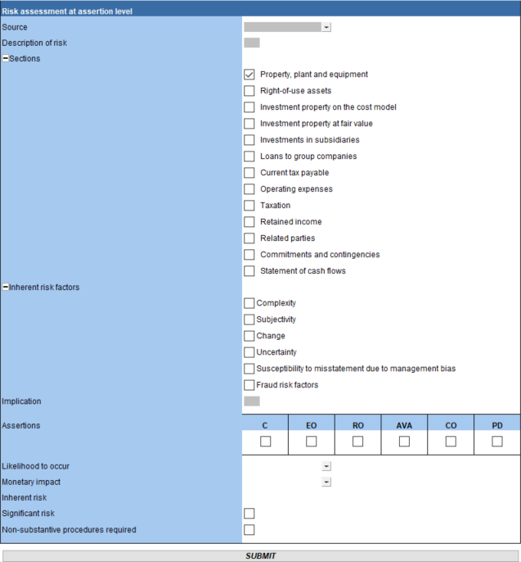

Update process
Due to the renewed document manager the financial statements and Probe must update simultaneously to conform with the new sections and related changes to provide a seamless integration.

A warning message will appear, and you will be prevented to continue if the selection is not made.
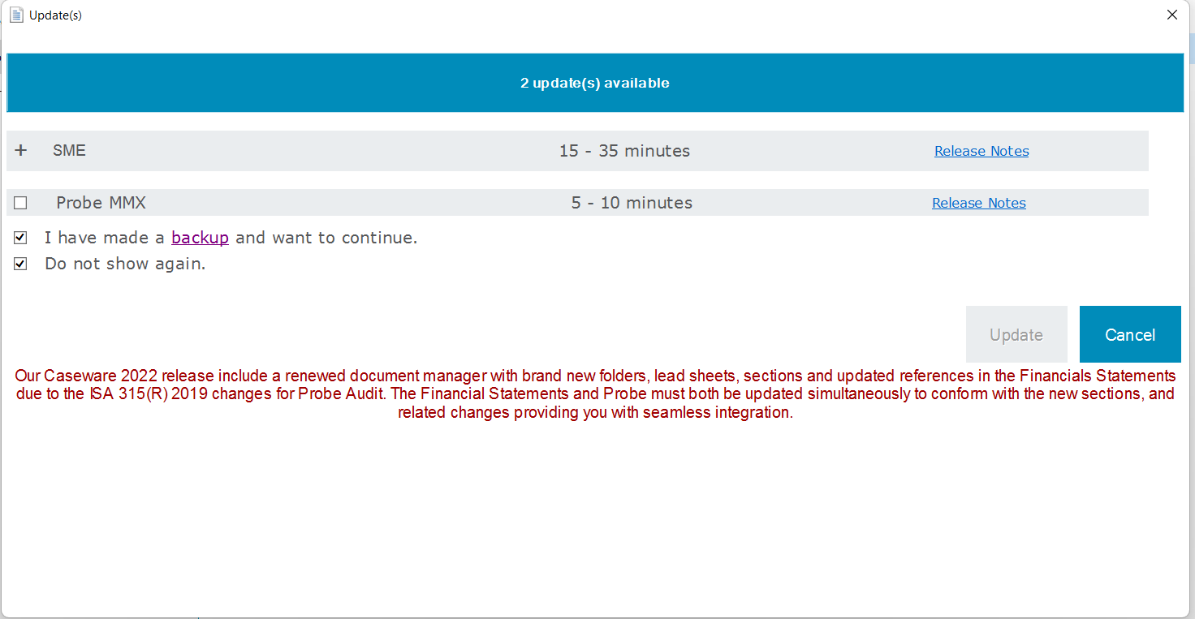

Fixes
The following list is a brief description of fixes that have been made:
- 10.21 Engagement letter – The page number printed on the first page.
- 02.40 Evaluation of misstatements – There were issues on the cash flow statement:
  - Duplicated items
  - Comment fields that were linked
- 02.90 Report to management and those charged with governance – When a section did not have weaknesses, and you click on Add, a new weakness was not added.
- 02.90 Report to management and those charged with governance – Weaknesses for financial statement level sections like Control Environment did not show on the document map.
- Printing, for example:
  - 02.40 Evaluation of misstatements – Footer
  - 06.10 Compilation letter of representation – Not all paragraphs were justified
  - 06.21 Compilation engagement letter – Not all paragraphs were justified
  - 10.20 Engagement evaluation – Some procedures were in their own tables
  - 10.21 Engagement letter – Not all paragraphs were justified
  - 10.40 Time budget – Columns were not lining up
  - 10.51 Types and volumes of transactions – If in Audit, the document printed blank with no instructions
  - 10.51IDEA Types of transactions and terminology – If in Audit, the document printed blank with no instructions
  - 10.53 Understanding of accounting estimates – If in Audit, the document printed blank with no instructions
  - 10.70 Identify material items and areas likely to be misstated – If in Audit, the document printed blank with no instructions

Known issues

Cosmetic items
- Document notices in certain documents are not consistent throughout the product, namely 10.51IDEA, 12.25 and 02.55
- Document 12.25 showing “Level 1” on top of each section.
- Document map still referring to EQCR instead of EQR in document 10.20.
- Document 02.80 incorrectly named EQCR instead of EQR on update
- Document 02.20 refers to unqualified and document 02.50 refers to unmodified. They mean the same thing however these items will be aligned accordingly
- When in review, Work programs have a missing tag
- When inserting new procedures in work programs, they appear with misaligned tick boxes
- In 02.00, when in review, the tooltip for the Response column references the focused enquiries document instead of the areas likely to be misstated document

Engagement partner sign off drop down
The sign offs that have these dropdowns in question should allow you to select the name of the engagement partner but currently, the names that pull through may erroneously not show the required persons. This is a known issue and will be resolved in a future release. The documents in question are:
- 02.00 Partner sign off
- 02.20 Going concern conclusion
- 02.55 Key audit matters
- 06.20 Compilation engagement evaluation
- 10.20 Engagement evaluation
- 12.30 Planning memorandum

Inserting and deleting of rows
- In 11.50, under General IT Controls on the table “Identify IT Risks”, when deleting the main row, you will no longer be able to add a new row going forward. To be corrected.
- Inserted procedures, sub-procedures and subsub-procedures in work programs have incorrect and/or tooltips for the Cut off and Presentation & Disclosure assertions
- Inserted procedures, sub-procedures and subsub-procedures in work programs for specifically Test of Controls and Significant Risk Responses have outstanding tickboxes. Only assertions that show are for Cut off and Presentation & Disclosure
- In 02.40, under Qualitative disclosure, adding or deleting a row causes the program to run indefinitely. The only workaround at this time is to manually kill the document using the Task Manager

Recording dialog
- In 11.50, when raising a control under the Accounting records section, two controls are raised instead of one, the captured control and a blank one.
- In 11.50, the section is not automatically ticked for you on the dialog when raising a control

Work program items
- Duplicated procedure in Review. “Complete the focused enquiries document for…”. It shows under required procedures and under Presentation and disclosure
- When having selected “using the work of another” in 10.70 in a review engagement, the corresponding procedures do not appear in the work program for Revenue.

Other items
- In 12.25, each section has an assertion level bookmark with a hyperlink to inherent risk assessment in 11.60. The link is broken and shows a bookmark error when it is clicked on

Audit

ISA 315 (2019 Revised)
The following significant changes included in ISA 315 (Revised 2019), Identifying and Assessing the Risks of Material Misstatement, together with the conforming and consequential amendments to other international standards, are addressed in this release:

Obtaining and understanding
Stronger focus on using technology in an audit which include the understanding of the use of IT by the entity and the understanding of IT risks and IT general controls in certain circumstances (ISA315.19, ISA 315.25(a)(iv) and ISA315.26(b)&(c)).

Clarifying the following related to the entity’s system of internal control:
- An understanding of the information system needs to be obtained for significant classes of transactions, account balances and disclosures (hereafter referred to as SCOTABD), i.e., for those COTABD for which relevant assertions were identified (ISA315.25(a)).
- Which controls need to be identified for purposes of evaluating the design of a control and determining whether the control has been implemented (ISA315.26(a).
- When and to what extent work will be needed for indirect and direct controls (ISA315.26(b)&(c)).

Identifying and assessing risks of material misstatement
- Included inherent risk factors to focus the auditor on the susceptibility of assertions to misstatement (ISA315.31&12).
- Introduced the spectrum of inherent risk to assist the auditor in making a judgement, based on the likelihood and magnitude of a possible misstatement, on a range from higher to lower, when assessing risks of material misstatement (ISA315.31).
- Clarified that the auditor will assess the inherent risk for the identified risks of material misstatement at assertion level for COTABD (ISA315.31). The auditor shall assess the inherent risk by assessing the likelihood and magnitude of misstatement and placing it on the spectrum of inherent risk.
- Included the “Stand-back” provision to evaluate the completeness of SCOTABD at the end of the risk assessment process (ISA315.36).

Responses to assessed risks
- The auditor will be required to design and perform substantive procedures for each material COTABD.
- The auditor will not be required to test all assertions related to material COTABD (ISA330.18 read with A42). The auditor will have designed substantive procedures for SCOTABD, i.e., those with relevant assertions. Furthermore, the auditor will apply professional judgements and select the assertions to be tested for material COTABD.

Assertions
There are now 6 assertions in Probe:
- Completeness (C) – Definition changed
- Existence and Occurrence (EO) – Definition changed
- Rights and Obligations (RO) – Definition changed
- Accuracy, Valuation and Allocation (AVA) – Name, abbreviation and definition changed
- Cut-off (CO) – New assertion
- Presentation and Disclosure (PD) – New assertion

The change in assertions affects:
- FIRMSETT Probe Firm Settings
- All documents with references to assertions

Core and Extended options
Engagement teams can now elect to include procedures in their engagement file that address the minimum requirements of the ISAs, being the “Core” profile, or they can elect to include “Extended” procedures. The “Extended” option not only include the procedures based on the requirements of the ISAs; it also includes additional audit procedures, questions and considerations based on the application and other explanatory material.

The extended procedures will especially benefit inexperienced engagement team members that is not as familiar with the practical application of the ISAs. A firm might also elect to apply “Extended” on engagement based on your own audit documentation policies.

The engagement team elects between “Core” and “Extended” by answering a question in 10.20 Engagement evaluation.

Risk assessment procedures (RAP) to obtain understanding of the entity and its environment
10.55 (New), 11.20, 11.25 (11.40 previously), 11.30 and 11.50 now includes a section at the top of the document that will prompt the auditor to elect the type of risk assessment procedures performed.

The auditor will be required to perform all the risk assessment procedures, namely inquiries, analytical, observation and inspection, whilst obtaining the understanding of the entity, but is not required to perform all of them for each aspect of the understanding (ISA 315.14). Furthermore, the auditor will be prompted to document the sources of information from which the understanding was obtained, and the risk assessment procedures performed (ISA315.38(b)). When the auditor selects inquiries, the auditor will be prompted to record the name and detail of the inquiree and date of the inquiry.

Transactions related to account balances (TRAB)
As noted in par 2.2, transactions related to account balances (TRAB) will now be included in the class of transaction to determine whether the account balance or class of transactions are material.

Examples of TRAB include depreciation, amortisation, profit or loss with disposal or derecognition of assets, fair value adjustments, revaluation adjustments, impairment and reversal of impairment.

It is still deemed efficient and effective to obtain and understanding of these transactions related to the account balance when the understanding of the account balance is obtained. Therefore, the TRABs are included as tick boxes in 10.51 - Types and volumes of transactions in the account balance section. For example, the auditor will be prompted to consider “Depreciation” in section 305 PPE as part of obtaining the understanding of PPE, including significant estimates.

It is also deemed effective and efficient to test TRAB when the relevant assertions related to the account balances are tested. For example, when the auditor elects to test allocation, valuation and accuracy (AVA) of PPE, the auditor will recalculate the cost less accumulated depreciation and impairment of selected items. As part of aforementioned, it will be deemed appropriate to test depreciation for those selected items. The audit procedures for TRAB, in our example depreciation, will be included in the work program of the account balance. The work programs now include a new sub-section “Transactions related to the account balance” where the TRAB procedures are located.

Refer to flow diagram “Inclusion of audit procedures in work programs” for further information on what basis audit procedures related to TRAB will be included in the work programs.
The auditor will continue conclude on the relevant and selected assertions for the account balance.

Work Program Procedures
This release contains significant changes on the conditions when work program procedures switch on in the relevant work programs.

Work program procedure changes include only showing procedures with relevant and selected assertions in work programs (see para 3.1.3) as well as the inclusion of TRAB’s (see para 3.5) to include activating procedures from other sections. The number of work programs have also increased due to the increase in number of sections (see para 2.1) which in turn have an increase in the number of procedures.

We take the utmost care with the automation of our procedures to show procedures only when they are relevant. Our procedures went through a process of quality assurance testing and code review by multiple parties. Due to the scale of the release, we can however not guarantee that all procedures will be working as expected. During 2023 we will be continuing to test procedures in work programs and provide hotfixes as and when appropriate.

As part of defining your audit plan and strategy we remind audit teams to also review (as was the requirement before) planned work program procedures for relevant and selected assertions to ensure that all the procedures required are included in the work program for execution.

In the meantime, when you come across a procedure not showing when you expect it to show, or vice versa, please get in contact with our support team so that we can be made aware and investigate to provide a fix.

We understand that you cannot always wait for a hotfix to be deployed or for a support call to be returned so for those scenarios, you are welcome to:
- Ignore procedures that should not be showing
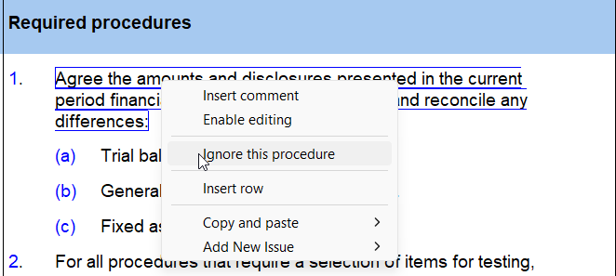
- View and Add hidden procedures that should be showing.
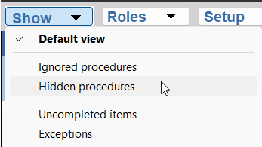

Audit procedures flowchart
YES
YES
YES
YES
NO
NO
NO

Pre-engagement planning
Matter identified | ISA ref | Comment
10.50 Gathering of information
The overall audit considerations such as use of experts, other practitioner, inventory count and obtaining confirmations were moved to 12.20 Audit plan and strategy. |  | The auditor will now first perform the risk identification and assessment for all COTABD and based on their risk assessment formulate their audit plan and strategy which includes the decision to use experts, other practitioners and obtaining confirmations.
Probe Small: The auditor will no longe0r elect for which COTABD a detailed risk assessment will be performed. | ISA 315.28 &31 | The election for “Small” was removed since the auditor will not be required to assess the inherent risk per assertion for each COTABD. The auditor will identify the risk of material misstatement at the assertion level for COTABD and then assess only the identified risks of material misstatement at the assertion level.
A procedure now prompts the auditor to consider whether automated tools and techniques should be used to assist with obtaining and understanding of the entity and its environment and to perform risk assessment procedures. | ISA 315.19(a) read with A57
Walk-through procedures - When the firm elected in Probe Firm Settings that walk-through procedure should be elected per engagement, a procedure will appear providing the engagement team with the option to perform walk-through procedures for all SCOTABD. |  | The firm can elect in Probe Firm settings that walk- through procedures are:  - Not required  - Required for all audit engagements  - Elected per audit engagement  When elected for all audit engagement or in 10.50 for the specific engagements, a walk-through procedure will be included for each SCOTABD on 11.50.  A walk-through is not specifically required in accordance with ISA 315. ISA 315.25(a)-(c) or ISA 315.14. Reading ISA 315.A101 it appears that a combination of RAPs is recommended/best practice.
10.51 Types and volumes of transactions
The lead sheets section includes information about the COTAB, the categories of the COTAB and TRAB. |  | The information may assist the auditor with the execution of the risk assessment procedures (RAPs) noted below. It may provide evidence of what type of transactions or balances are included in the section and how it compares to the prior period.  A description column can be used to document audit evidence obtained whilst performing the RAPs.
Procedures, deemed to be risk assessment procedures, moved from the work programs to 10.51 to assist the auditor to identify inherent risk factors and to identify and assess the risks of material misstatement. |  | The auditor will be prompted to perform the following risk assessment procedures for each COTABD with a balance in the CY or PY:  1) Review the trial balance and obtain explanations for unusual accounts and accounts appearing to be incorrectly mapped.  2) Compare account balances per category with previous years and budgets, where relevant, and obtain reasons for unusual changes.  3) Consider whether the entity's selected accounting policy is consistent with the FRF.
The audit considerations such as use of experts, other practitioner, inventory count and obtaining confirmations were moved to 12.20 Audit plan and strategy. |  | The auditor will now first perform the risk identification and assessment for all COTABD and based on their risk assessment formulate their audit plan and strategy which includes the decision to use experts, other practitioners and obtaining confirmations.
10.55 Understanding the Information Technology environment (IT) (NEW)
Added new document to obtain an understanding of the complexity of the IT environment. | ISA 315.25(a) | Both the Core and Extended user will be prompted to obtain information about the IT applications, IT infrastructure and IT processes used by the entity.  The preliminary understanding is obtained to inform the auditor  Whether specialised skills are required to perform further risk assessment procedures, and  About the nature and extent of further risk identification and assessment procedures in planning.
Additional content provided for the extended user. |  | The extended option provides the following additional content based on Appendix 5 and 6 of ISA 315 (2019 Revised).  Additional questions to identify the characteristics of the IT environment and to evaluate the complexity of the IT environment based on Appendix 5 and 6 of ISA 315 (2019 Revised).  Determine whether specialised IT skill is necessary to perform risk assessment procedures. If yes, perform procedures related to the use of auditor's expert.  Determine which COTABD are impacted by the identified characteristics of the IT environment.

Planning and risk assessment procedures
Matter identified | ISA ref | Comment
Identify and assess RMM at FS level: 11.20, 11. 25 and 11.30
The auditor will now assess individually identified inherent (IR), fraud (FR) or control (CR) risks at financial statement level (FS level). | ISA315.30 | ISA 315.30 requires the auditor to assess identified risks of material misstatement at the financial statement level. To date the auditor was only required to determine whether an individual risk at FS level is a significant risk and to evaluate the overall IR, FR and CR at FS Level.  The existing risk levels used for IR at FS Level (high, medium or low), CR at FS Level (high, medium or low) and FR at FS Level (high or low) will be used.
The overall IR, FR and CR at FS Level will be automated based on the auditor’s assessment of the individual IR, FR and CR at FS Level. |  | When more than one IR, FR or CR at FS Level was identified and recorded with different risk assessments, the highest risk assessment of the individually assessed risks will be used to automate the overall IR, FR or CR at FS Level.  For example, when the auditor assessed the one IR at FS Level as low and another IR at FS Level as medium, the overall IR at FS Level will be populated as medium.  When no individual IR, FR or CR at FS level was identified and recorded, the overall IR, FR and CR at FS Level will indicate “Not yet assessed” and the auditor will be required to select “Low”. (Known issue – Low is indicated and not “Not yet assessed”)
The auditor will evaluate whether the entity’s processes for the different components of the system of internal control are appropriate. | ISA315.21 (b),22(b), 24(b) and 25(c) | The auditor will no longer be required to assess the different components of IR and FR at FS Level separately in Probe Large.
Conclusion questions are added to prompt the auditor to determine whether management identified the risks at FS level and if not, the reason for failure to do so. | ISA315.23
Response to assessed RMM at FS level: 11.20, 11. 25 and 11.30
For each identified and assessed IR, FR and CR at FS level, the auditor will select overall response(s) to address the assessed risks of material misstatement at the financial statement level. | ISA330.5 read with A1 | The auditor will be given a list of possible overall responses per ISA 330.A1 to select from, except for the option “Changes to extent of further substantive procedures” as this option will be facilitated through the inclusion of the remaining IR, CR and FR in the Probe ROMM calculation. An “other option” is also provided.  The selected overall responses will be included in the conclusion section. The auditor is also prompted in the conclusion section where in the audit plan further action might be necessary, for example when the auditor selected use of experts as an overall response, the auditor will be prompted to select the use of experts on 12.20.
For an identified and assessed FR at FS Level, the risk will automatically be ticked as a significant risk and the overall responses required by ISA 240 will automatically be selected. | ISA240.29 | The auditor will not be able to override the required overall responses.
When the overall, IR, FR or CR at FS level, based on the individually assessed risks, is assessed as higher than low, the auditor will assess whether they want to increase extent of work on all relevant and selected assertions: |  | The auditor will consider to what extent do they expect that the selected overall response, will be sufficient to respond to the assessed RMM at FS level before increasing the ROMM at assertion level and changing to nature and extent of further substantive procedures.
11.20 Understanding of entity and its environment
Procedures were updated to address all aspects for which the auditor is required to obtain an understanding of the entity and its environment and the applicable financial reporting framework. | ISA315.19
11.25 Fraud risk assessment
The number of the document changed from 11.40 to 11.25.
11.30 Information system and control activities
Name of document changed from “Control risk assessment – Design and implementation” to “Evaluation of internal control”
The objective of the document is to obtain an understanding of the processes and procedures relevant to the entity’s  Control environment,  Risk assessment process, and  Process to monitor the system of internal control  The understanding of the entity’s information system and communication, including the financial reporting process and journals, moved to 11.50 Information system and control activities. | ISA315.21 (a),22(a) and 24(a) & (b). | The auditor is now prompted to document the understanding of the processes and procedures implemented by the entity and to explain how their understanding of the process were verified.  The auditor will no longer be required to describe the control procedure and explain how the control procedure was implemented.
Procedures were updated to address all the aspects of the entity’s process for which the auditor should obtain an understanding of the internal control components. | ISA315.21 (a),22(a) and 24(a) & (b).
The auditor will evaluate whether the process for each internal control component implemented by management, is deemed appropriate or not. | ISA315.21 (b),22(b), and 24(c)
11.31 Control risk assessment – Testing of controls
Removed. |  | The auditor no longer reduces the CR at FS level and ultimately the ROMM at assertion level by identifying, evaluating and testing controls.  The auditor will now assess the control risk based on the understanding of the entity’s processes related to the internal control components and the evaluation of its appropriateness.
11.50 Information system and control activities
Change name of document from “Control activities design and implementation” to “Information system and control activities”.
The objective of the document is to obtain understanding of the entity’s information system and communication relevant to the preparation of the financial statements and where relevant, to obtain an understanding of control activities. | ISA315.25 (a) and  ISA315.27
The auditor will use the new feature “Record control” to record the following details related to identified controls on 11.50:  Description of the control.  Whether the control is designed effectively to address the ROMM of assertions.  Explain how the implementation of the control was verified.  Conclude whether the control was implemented.  Assign the control to the appropriate assertion (except for sections “Financial reporting process”, “Journal entries” and “General IT controls”)  Whether reliance is intended.  If reliance is intended, the description of the test of control. |  | The detail related to the control will pull through to the “Identify and evaluate controls” table on 11.50.  When reliance is intended, the detail of the control and the test of control will pull through to relevant work program.  The auditor will no longer record the description of the control on 11.50 directly or in the risk record mode. The test of control will no longer be recorded on either 12.20 or in the risk record mode.
The following sections will always be enabled on 11.50:  Financial reporting process  Journal entries  Related parties | ISA315.25 (a)(iii)  ISA315.26 (a)(ii)  ISA550.14 | For these sections the auditor is prompted to obtain an understanding of the information system and to answer a question whether management established controls.  When the auditor concluded that management did establish controls, the auditor will be prompted through the “Record control” icon to record the details of the control.  When the auditor concluded reliance on the controls are intended, the detail of the control and test of controls will pull through as follows:  Financial reporting process will pull through to 18.10 Financial statement preparation.  Journal entries will pull through to 16.10 Accounting records.
Other sections on 11.50 will be enabled when an inherent risk was recorded for the section, i.e., it is deemed to be a SCOTABD. | ISA 315.25(a) | The auditor is required to obtain an understanding of the entity’s information processing activities for SCOTABD.
The auditor can also elect to enable any section not yet enabled to identify and evaluate controls when the auditor concluded that it may assist them with the identification and assessment of risks of material misstatement at assertion level. | ISA 315.26(a) (iv) | Voluntary enabling of sections on 11.50 can be done by right click on the section name and selecting enable section.
Procedures were updated to address all the aspects of the entity’s process for which the auditor should obtain an understanding of the entity’s information processing activities. | ISA 315.25(a)
Optional Walk-through procedures included based on the selection in Probe Firm Settings and 10.50 Gathering of information.
The auditor will be required to determine whether controls exist and to perform design and implementation for identified controls in the following circumstances:  Journal entries,  Related parties,  For risks classified as significant risks in 11.60/Risk record mode,  For risks for which substantive procedures alone do not provide sufficient appropriate audit evidence in 11.60/Risk record mode,  When the auditor indicates that it intends to test the operating effectiveness of the controls in Control record mode, and  When the auditor elects to identify controls as part of your risk identification and assessment process. | ISA315.26 (a)(ii)  ISA550  ISA315.26 (a)(i)  ISA315.26 (a)(iii)  ISA315.26 (a)(iii)  ISA315.26 (a)(iv) | Journal and related parties’ sections will always be activated, and the auditor will be required to answer a question related to controls implemented by management.  Any significant risk recorded will pull through to the relevant section in 11.50 and the auditor will be prompted to record a control that mitigates the significant risk (if any).  Risk for which substantive procedures alone do not provide sufficient appropriate audit evidence, as selected in the risk record mode, will also be included in the relevant section (similar to significant risk).  For all sections related to SCOTABD (enabled by the software) or those sections enabled by the user, the auditor can elect to test the operating effectiveness of controls.
IT applications and environment: Per section, for all identified controls, the auditor will be asked to determine whether the controls are dependent on IT applications and other aspects of the IT environment. | ISA 315.26(b) | For identified controls, the auditor is required to identify the risks and mitigating general IT controls related to the IT applications and the IT environment when the identified controls are dependent on those IT applications.
“General IT Controls” section will be activated when the auditor indicates that the identified controls are dependent on IT applications and other aspects of the IT environment.  The auditor will assess whether the accounting software used or other aspects of the IT environment are subject to risks arising from the use of IT.  When the accounting software of IT environment are subject to risks arising from the use of IT, the auditor will be prompted to complete the “Identify and evaluate control” table and record general IT controls. | ISA 315.26(b)&(c) | The auditor can document the description of the risk arising from IT in the “Identify and evaluate controls” table.  The “Record control” dialogue should be used to record the description of the general IT control that management has implemented to mitigate the risk arising from the use of IT.  The auditor can elect to test the general IT controls. The detail of the general IT control and the test of control will pull through to 19.10 General IT controls work program (NEW).
The auditor will evaluate the appropriateness of the entity’s information system and communication to support the preparation of the financial statements in accordance with the FRF. | ISA 315.25(c) | The evidence gained will primarily be used for the identification and assessment of the ROMM at the assertion level, but it should also be considered whether the evidence gained affects the identification and assessment of CR at the FS Level (ISA 315.A95 refers).
11.60 Risk assessment at assertion level
The auditor will only assess the inherent risk (IR) for relevant assertions, i.e., assertions for which a risk of material misstatement has been identified. | ISA315.31 | In accordance with ISA315(R).31 the auditor will only be required to assess the IR for the identified risks at the assertion level.  The auditor will no longer be required to assess the ROMM for all the assertions for all COTABD.
Risk record button was updated to include:  Inherent risk factors: Complexity, Subjectivity, Change, Uncertainty, Susceptibility to misstatement due to management bias and Fraud risk factors  IR assessment – calculated field | ISA 315.31&12
The IR assessment is calculated for each recorded IR using the auditor’s assessment of likelihood and magnitude and the Probe Audit Methodology Inherent Risk (IR) Assessment table. | ISA315.31 | The Probe IR Assessment table will be used as the spectrum of IR. No changes were made to the Probe IR Assessment table.
The IR assessment of the relevant assertions, as recorded in the risk record mode, will pull through to the “Inherent risk assessment at assertion level” in the risk assessment table. |  | Where there is more than one IR identified for a relevant assertion, the highest calculated IR assessment will be used (and not an average). Based on this assessment, the auditor will perform the required extent of work for the IR identified with the highest IR assessment.  The calculated IR assessment did not automatically pull through to the IR assessment at assertion level in the risk assessment table. The auditor was required to capture the IR assessment at assertion level per sub-section and section in the risk assessment tables on 11.60.  The improved automation will eliminate the risk of inconsistencies between the IR assessment in the risk mode and the risk assessment tables.
For those assertions for which no risks were identified, i.e., it is not deemed a relevant assertion, the inherent risk at assertion level in the risk assessment tables will reflect “No IR” and it will be included in the Probe ROMM calculation at low.
The auditor will not be required to assess the fraud risk at assertion level separately. |  | The separate assessment of fraud risk at assertion level is removed since the auditor is required to consider fraud risk factors, as one of the inherent risk factors, when identifying and assessing risk of material misstatement.
The assessment of whether an identified risk, other than fraud, is significant will remain a judgement by the auditor.  For all fraud risks identified, the “Significant risk” column will be populated with a tick mark. | ISA315.32  ISA 240.27 | The assessment will not be automated based on the result of the inherent risk assessment and where on the spectrum it falls.  When the calculated inherent risk is High the auditor will be prompted to consider whether the identified risk is as significant risk.
11.10 Risk analysis summary
ROMM Calculation was updated with:

Risk assessment at financial statement level: The remaining IR, CR and FR at financial statement level, after taking into account the expected assurance from the overall responses selected, are used.
Risk assessment at assertion level for fraud risk is removed from the calculation.
Risk assessment at assertion level for inherent risk: “No IR” is included at the same level as a Low IR.

Audit planning
Matter identified | ISA ref | Comment
12.20 Audit plan and strategy
The auditor can now elect audit considerations, which include the use of management's expert, auditor's expert, external confirmations, work of internal audit and service organisation, after they have identified and assessed the risk of material misstatement. |  | The auditor will first select overall whether they want to use experts, confirmations, etc and then they will select the specific sections for which they plan to use it.  Based on the selection, the relevant audit procedures will be included in the appropriate work programs.
The following information in addition to the Risk of Material Misstatement at assertion level, now appears in each section:  The inherent risk assessment at assertion, and  Select assertions for testing. |  | The IR assessment at assertion level will provide the auditor with an indication of the relevant assertions, i.e., those assertions for which a risk at assertion level were recorded.  The relevant assertions will be ticked to indicate that those assertions will be tested.  The auditor can select other assertions for testing (hereafter referred to as ‘selected assertions’).  Audit procedures related to relevant and selected assertions will be included in the relevant work programs.
Material COTABD not deemed to be SCOTABD, i.e., without relevant assertions.  The auditor will be required to perform the stand-back provision-procedure.  A red warning will prompt the auditor to select at least one assertion for the material class of transactions or account balance.  The auditor will be able to select assertions, in addition to relevant assertions, for material COTABD. | ISA 315.36  ISA 330.18 read with A42 | The software will identify material account balances and classes of transactions for which no relevant assertion was identified.  A stand-back provision procedure will be added to the appropriate section to evaluate whether the conclusion reached, that there is no relevant assertion, remains appropriate.  The auditor can select the assertion(s) in the “Select assertions for testing” line.
12.10 Manager planning checklist
Procedures added to check compliance with requirements of ISA 315 (2019 Revised).
12.30 Planning memorandum
Added discussion point related to professional skepticism to the “Planning meeting notes” section/procedure
Added warnings to inform the auditor that overall responses were selected on 11.20, 11.25 and 11.30 that requires further action.

Execution – Lead sheets and working papers
Matter identified | ISA ref | Comment
Work programs
Only audit procedures related to selected and relevant assertions will be activated on the work programs. |  | Refer to flow diagram.

Review

Conforming amendments will be made to the review documents for the final release.

New sections
With the new changes to ISA 315, our review documents have been altered to align with the new sections that have been created namely:
- 10.70 Identify material items and areas likely to be misstated
- 15.10 Focused enquiries working paper
- All work programs
- 02.00 Partner sign off

Likely to be misstated recording dialog
The functionality to record LTBMs has been updated in line with the newly facelifted risk dialog.

Refer to 2.4.3 Recording dialog

Compilation

New sections and leadsheets
Due to the separation of the equity and non-current liabilities compilation program into equity compilation program and non-current liabilities compilation program respectively, a new program was created to accommodate the change. A corresponding change was created for the leadsheets as well. Further changes have been made to the existing sections as well to renumber the compilation programs and their leadsheets to accommodate the newly created sections.

Refer to Annexure A – Sections for detailed changes.

Update document summary
Refer to par 2.5 for information on the 2022 Update.

Due to the significant number of changes in the document manager, new sections and move of the procedures within work programs with the redesign of the recording dialog, most documents will not retain any information and will be completely replaced by a new version in the release.

Risks and controls will not be retained on update as section numbers have changed.

User inserted procedures will also not be retained on update as sections are new and users are required to insert procedures manually in the new work programs.

Contact Us

Main Contact Details
Adapt IT Reception | +27 10 494 1000

Help Desk Direct Extension
E-mail Caseware Support | support@casewareafrica.co.za

Other Important Details

Register at success.casewareafrica.com for easy access to frequently asked questions, upgrades, downloads, and technical documentation.

Email us at info@casewareafrica.co.za regarding:
Feedback
Ideas on service or products
Product information
Account or license information
Any other queries

Follow us
 | Caseware Africa – South Africa
 | Caseware Africa – South Africa
 | Caseware Africa – South Africa
 | Caseware Africa – South Africa

